**Econ 206/Test 2 (Version A)**

Write your name on your scantron (-2% if not).

For questions 1-4, use the following information regarding the number of customers complaints for a five-week period: Week 1 = 20, Week 2 = 50, Week 3 = 20, Week 4 = 20, Week 5 =30

1. The standard deviation of complaints per week is (apx)

a. 15 b. 10

c. 7 d. 13

2. The median number of complaints per week is

a. 10 b. 20

c. 30 d. 50

3. For the first week, the standardized value for the number of complaints is (apx)

a. 0 b. –0.6

c. -1.7 d. –2.2

4. The statistical measure that summarizes the dispersion of a data set is

a. the skewness coefficient b. the standard error

c. the standard deviation d. the median

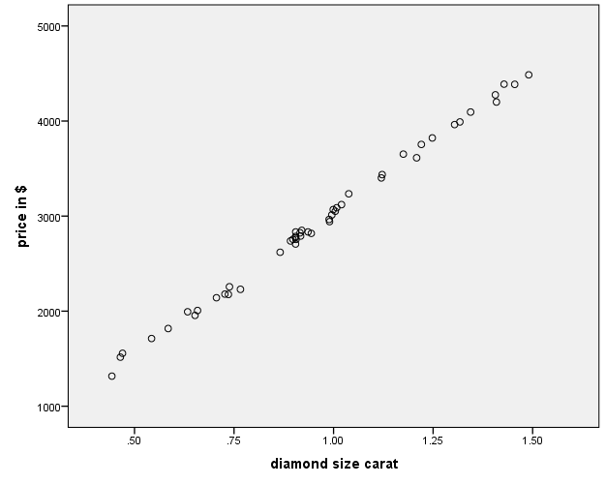

5. The figure above displays a scatterplot for diamond size and diamond price. The correlation coefficient in this case would be close to

a. -1.0 b. 0.0

c. 0.5 d. 1.0

**Regression: Diamond Prices (in $) and Diamond Size (in karats)**

|  |  |  |  |  |  |  |  |  |
| --- | --- | --- | --- | --- | --- | --- | --- | --- |
| **Model Summary** | | | | | | | | |
| Model | | R | R Square | | Adjusted R Square | | Std. Error of the Estimate | |
| 1 | | .998a | .997 | | .997 | | 47.600 | |
|  | | | | | | | | |
| Coefficients | | | | | | | | |
| Model | | | | Unstandardized Coefficients | | | | Standardized Coefficients | | t | Sig. |
| B | | Std. Error | | Beta | |
| 1 | (Constant) | | | 50.599 | | 25.368 | |  | | 1.995 | .052 |
| diamond size carat | | | 2995.155 | | 25.357 | | .998 | | 118.118 | .000 |
|  | | | | | | | | | | | |

6. The results for the regression above imply that

a. at a price of $0, karat size is 0

b. at a price of $50, no diamonds would be purchased

c. at karat size of 0, price is $50

d. none of the above

7. The results for the regression above imply that (ignoring decimal places)

a. a 1 karat increase in size increases price by $2995

b. a 10 karat increase in size increases price by $2995

c. a 0.5 karat increase in size increases price by $299

d. none of the above

8. In graphical terms, regression analysis amounts to

a. finding the table which lists corresponding outcomes for different categories of two variables

b. finding the probability of values greater than or less than the mean for a variable

c. computing the probability of finding two variables that are identical

d. fitting a line to pairs of values that have been plotted for two variables

9. The R-square value indicates that

a. Diamond size explains diamond price with 99.7% accuracy

b. When diamond size increases by 1 unit, price increases by 0.997 units

c. Diamond prices and diamond size are related by not strongly

d. none of the above

10. The regression output above expressed in equation form would be

a. Diamond Price = 2995 + 50*Diamond Size

b. Diamond Price = (2995 + 50)*Diamond Size

c. Diamond Size = 50 + 2995*Diamond Price

d. none of the above

The table below contains results for accounts broken down by the account supervisor (A, B) and whether the account had an irregularity or not (No=0, Yes=1). (Actual counts given in table)



11. The actual number of irregular accounts for Supervisor B is

a. 50 b. 10

c. 15 d. 750

12. The total number of irregular accounts is

a. 15 b. 50

c. 100 d. 5

13. The expected number of irregular accounts (=1) for supervisor A is

a. 7.5 b. 10

c. 15 d. 5

14. Suppose that the expected number of irregular accounts for A is 20 and for B is 5. This

would indicate that

a. account supervision and account irregularities are not related to each other

b. account supervision by B appears to increase account irregularity

c. account supervision by A appears to increase account irregularity

d. account supervision by A and B appear to be randomly assigned

The table below presents regression results using Air Fair (**in dollars)** as the dependent variable and Distance to the destination city (**in miles**) as the explanatory variable.

|  |  |  |  |  |  |  |
| --- | --- | --- | --- | --- | --- | --- |
| *Air Fares Regression* | |  |  |  |  |  |
| Multiple R | 0.70 |  |  |  |  |  |
| R Square | 0.49 |  |  |  |  |  |
| Adjusted R Square | 0.46 |  |  |  |  |  |
| Standard Error | 43.29 |  |  |  |  |  |
| Observations | 21.00 |  |  |  |  |  |
|  |  |  |  |  |  |  |
| ANOVA |  |  |  |  |  |  |
|  | *df* | *SS* | *MS* | *F* | *Significance F* |  |
| Regression | 1.00 | 33683.07 | 33683.07 | 17.97 | 0.00 |  |
| Residual | 19.00 | 35612.74 | 1874.35 |  |  |  |
| Total | 20.00 | 69295.81 |  |  |  |  |
|  |  |  |  |  |  |  |
|  | *Coefficients* | *Standard Error* | *t Stat* | *P-value* | *Lower 95%* | *Upper 95%* |
| Intercept | 157.61 | 21.63 | 7.29 | 0.00 | 112.34 | 202.88 |
| Distance | 0.08 | 0.02 | 4.24 | 0.00 | 0.04 | 0.13 |

15. Which of the following statements is accurate based on the regression table:

a. All cities in the sample must have had air fares in excess of $157

b. For each additional dollar of air fare, distance increases by about 8 miles

c. a city 500 more miles in distance than another city would have a $197 higher predicted fare

d. For each 100 additional miles of distance, predicted air fare increases by about $8

16. What number indicates the (hypothetical) value of air fare if distance were zero

a. 0.49 b. 0.02

c. 157.61 d. 43.29

17. Written in equation form, the regression output above would be

a. Fare = 157 + 0.08*Distance

b. Fare = 157*0.08*Distance

c. Distance = 157 + 0.08*Fare

d. Distance = (157-0.08)*Fare

18. Choose the correct statement based on the regression output

a. The regression equation implies that Fare influences distance

b. Differences in distance explains about 49 percent of the differences in air fares

c. If the distance to a city were 0 miles, the (hypothetical) air fare would be $0.08

d. If the air fare were (hypothetically) 0, the distance would also be zero

**Regression of MLB Attendance with Game, Game Squared, Stadium Age,**

**Stadium Age Squared, and Prior Year Attendance**

|  |  |  |  |  |
| --- | --- | --- | --- | --- |
| **Model Summary** | | | | |
| Model | R | R Square | Adjusted R Square | Std. Error of the Estimate |
| 1 | .658a | .433 | .433 | 8967.942 |

|  |  |  |  |  |  |  |
| --- | --- | --- | --- | --- | --- | --- |
| **Coefficientsa** | | | | | | |
| Model | | Unstandardized Coefficients | | Standardized Coefficients | t | Sig. |
| B | Std. Error | Beta |
| 1 | (Constant) | 9912.378 | 180.061 |  | 55.050 | .000 |
| Gm | 74.318 | 3.778 | .287 | 19.670 | .000 |
| gm2 | -.386 | .022 | -.251 | -17.189 | .000 |
| STADAGE | -102.179 | 5.604 | -.201 | -18.234 | .000 |
| STADAGE2 | 1.080 | .064 | .185 | 16.849 | .000 |
| lattend | .616 | .004 | .633 | 172.919 | .000 |
|  | | | | | | |

19. The regression above

a. generates a slope between each X-variable and attendance

b. looks at the relationship between all pairs of variables

c. looks at linear relationships only

d. all of the above

20. The value above that expresses how well the X-Variables predict attendance is

a. 0.433 b. 0.658

d. 9912 d. none of the above

21. Put A for your answer

Correct Answers: 1 (all counted correct); 2-b, 3b, 5c, 5d, 6c, 7a, 8d, 9a, 10d, 11b, 12a, 13a, 14c, 15d, 16c, 17a, 18b, 19a, 20a